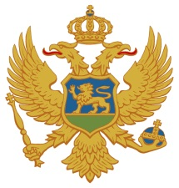 |  |  | 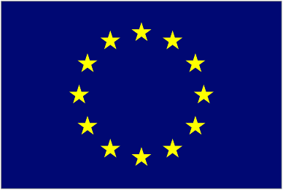

FINAL CONFERENCE

„THE IMPORTANCE OF HUMAN RESOURCE MANAGEMENT IN PUBLIC ADMINISTRATION“

11 April 2014
Regional School of Public Administration – ReSPA, Danilovgrad

Human Resources Administration Authority in cooperation with the Association of Municipalities of Montenegro, and with the support of the projects: AAM project „Support to the Human Resources Administration Authority“ and LOGINTS project „Support to the Implementation of the National Training Strategy for Local Self Government“ funded by the EU, is organizing the final Conference „The Importance of Human Resource Management in Public Administration“ in which activities implemented within project will be presented, with the purpose to contribute to the establishment of standards in the field of Human Resource Management.

09.45 – 10.00 Registration of participants
Welcome

The Importance of Human Resource Management in the Process of European Integration

10.00 – 10.50

Jadranka Vojinović, State Secretary of the Ministry of Internal Affairs,
Mitja Drobnič, Ambassador, Head of EU Delegation to Montenegro,
Svetlana Vuković, Director of Human Resources Management,
Refik Bojadžić, Secretary General of the Association of Municipalities of Montenegro,
Suad Musić, Director of Regional School of Public Administration

10.50 – 11.10 Coffee break

Presentation of the project

  - – 11.30

Jim Budds, Team Leader of the project “Support to the implementation of the National Training Strategy for Local Self Government”
Zoltan Kisfaludy, Team Leader of the project „Support to the Human Resources Administration Authority“

Concrete results and achievements of the project

11.30 – 11.50

Peter Miklič, Expert on the project “Support to the implementation of the National Training Strategy for Local Self Government”
Kaido Paabusk, Expert on the project „Support to the Human Resources Administration Authority“

The Importance of Human Resource Management – lessons learned - Trainers of the Human Resources Administration Authority and the Association of Municipalities

11.50 – 12.30

Mr. Mihailo Volkov, General Secretariat of the Government of Montenegro
Mr. Darko Mrvaljević, Municipality of Danilovgrad
Mr. Goran Božović, Municipality of Tivat
Mr. Žarko Ivanović, Merkator-CG d.o.o.

12.30 – 14.00 Lunch

