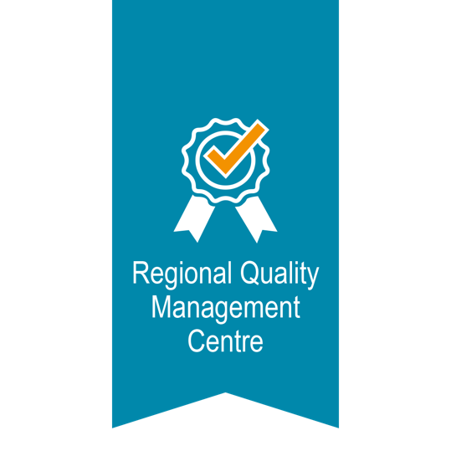

APPLICATION FORM

For Label "Effective CAF User"

The Label "Effective CAF User" – General Information
The Label "Effective CAF User" can be issued upon completed CAF feedback procedure provided by experienced CAF users, certified CAF evaluators.
Regional Quality management Centre of ReSPA has got the authority to act as the organiser of the CAF external evaluation that leads to issuing of the Label “Effective CAF User”.
In order to start with the CAF Professional External Feedback Procedure (PEF) you are requested to fill in this Application. Upon the receipt of you application and of verifying the fulfilment of application requirements, the RQMC of ReSPA will acknowledge that the application has been received and approved by written consent within five working days.
Name of the organisation / CAF User:
Address, place, country:
Contact person | Name and surname:
 | Position:
 | E-mail:
 | Telephone:
We hereby apply for the Label “Effective CAF User” by confirming the following:
- The application for the Label “Effective CAF User” was submitted 6-12 months from the date of receiving the final CAF Self-Assessment-Report.
Date of receipt of the CAF Self-assessment Report:
- The organisation is registered as CAF user at the ReSPA website on the following link: www.respaweb.eu.
Date of registration at ReSPA website:
- It is confirmed that the guideline „Effective CAF User – Guidelines for Applicants” has been read and the terms and conditions of the Label „Effective CAF User” have been accepted.
Yes ☐ | No☐

For the CAF user organisation (signature of authorised perosn)
Name and surname:
Date and place
Signature
Regional Quality Management Centre at ReSPA acknowledges the submission of the application for the Label “Effective CAF User” and that it is in conformity/it is not in conformity with both criteria to undergo Professional External Feedback Procedure.
For the RQMC user (signature of authorised person)
Name and surname:
Date and place
Signature
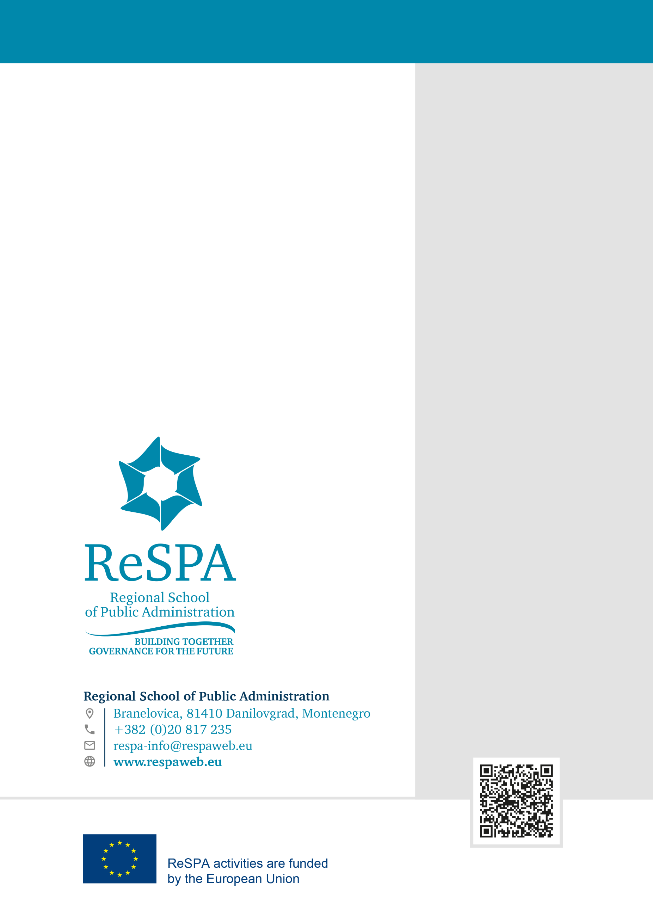

Article 1.3. Memorandum of Establishment and Operation of Regional Quality Management Centre

